/

## BlueClaws Baseball Academy

## REGISTRATION FORM, Page 1

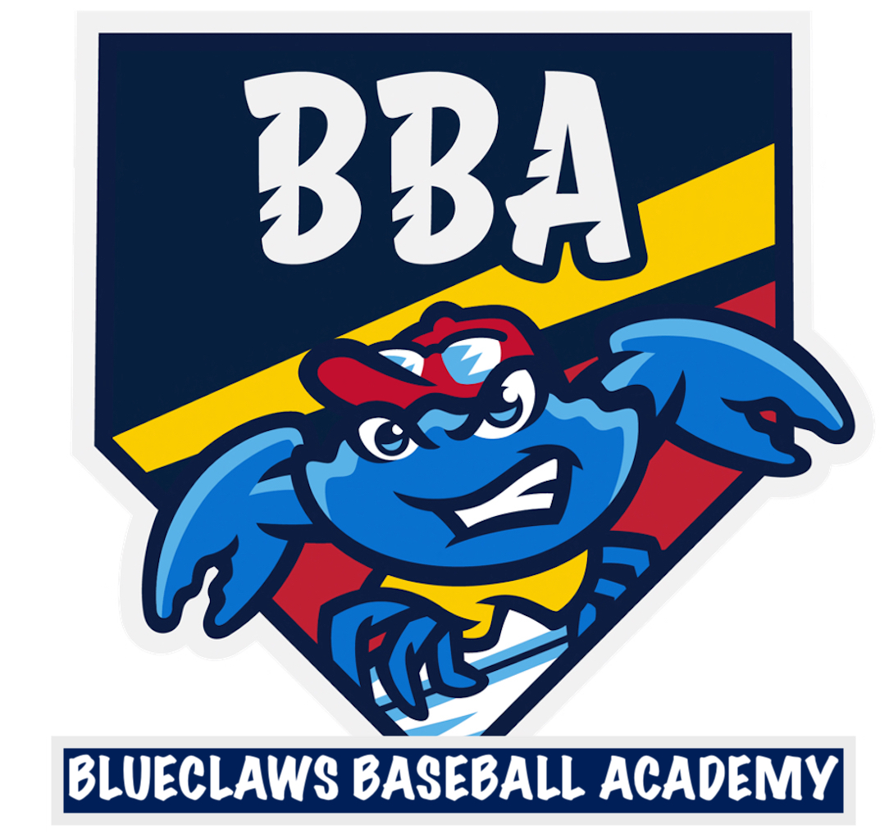

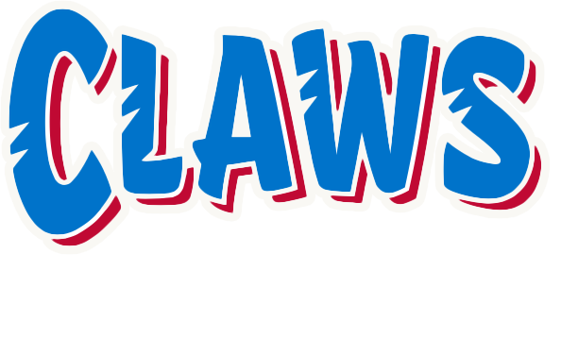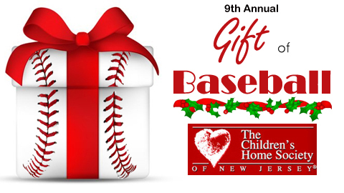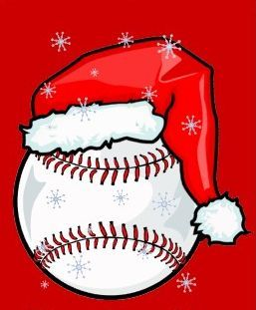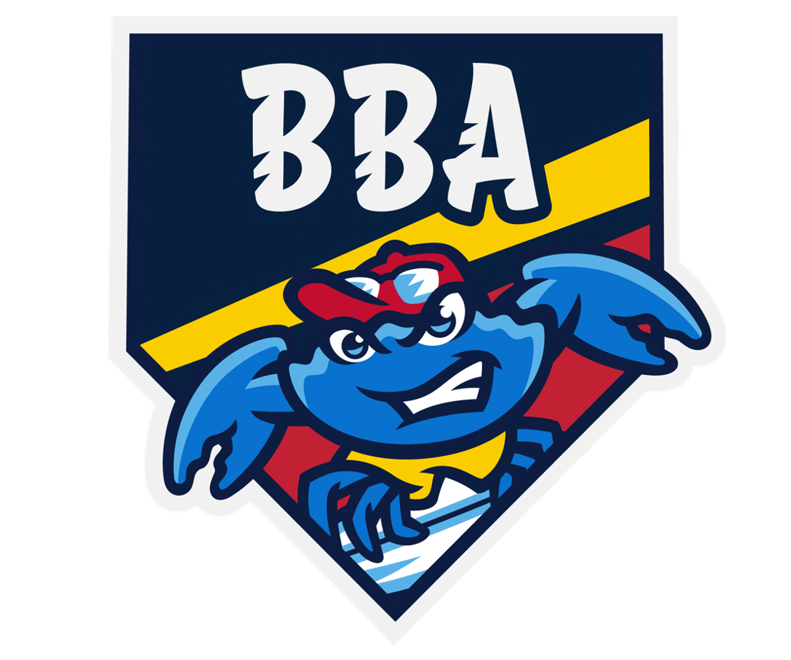

**Holiday Camp**

**12/27 – 12/28/24**

**Hitting 9:00-10:45a ($139)**

**Pitching 11:00-12:45p ($139)**

**Both Camps 9:00-12:45p ($249)**

**Ages 6 – 12**

**@ShoreTown BallPark**

**Please E-Mail registration to**:

bbacamps@blueclaws.com

**Please make payment via**

VENMO - @BBACLAWS

There will be no refunds or exchanges on reservations.

## BlueClaws Baseball Academy

## REGISTRATION FORM, Page 2

## Complete the registration form on page 1 and 2

**Child Name:____________________________________**

**Age: _____________________________________________**

**Camp Selection: ______________________________**

**Address:________________________________________**

**City: _____________________________________________**

**State, Zip: ______________________________________**

**Phone Number: _______________________________**

**Email: __________________________________________**

**Parent/Guardian Name:_____________________**

**Visit our website for more information or follow us on FACEBOOK, TWITTER, and INSTAGRAM!**

**www.blueclawsbaseballacademy.com**

**www.facebook.com/blueclawsbaseballacademy**

**TWITTER: @BBA_Claws**

**INSTAGRAM: blueclawsbaseballacademy**

#### SHORETOWN BALLPARK

#### 2 STADIUM WAY

#### LAKEWOOD, NJ 08701

**The BlueClaws Baseball Academy provides professional baseball instruction to youth players throughout the year at ShoreTown BallPark and is fully supported by the Jersey Shore BlueClaws, High-A affiliate of the Philadelphia Phillies. In the Fall of 2013, the BlueClaws and BlueClaws Baseball Academy started running High School travel teams, believed to be the first time that a Minor League Baseball team had their own youth teams playing home games in their Minor League stadium. Over 200 players from New Jersey and New York as well as International players from MLB China have played for the BlueClaws Baseball Academy.**

**About BBA**

The TWO-day HITTERS program is designed to teach players the essential techniques and philosophies of hitting. Each day players will work on pre-pitch, stride, balance, grip, bat path, and hitting zones, among other aspects of hitting along with games to make this a fun, informative environment. All camps have a 4:1 Player:Coach Ratio

This TWO-day PITCHERS program is designed to teach players the proper throwing mechanics to keep them healthy during the season. Pitchers will learn about mechanics, arm speed, arm slot, release point, and how to naturally produce velocity. Players will be given drills that they can use at home throughout the winter months to be ready to pitch when the season starts.

Each camper will receive 2 days of *advanced* instruction, use of the Jersey Shore BlueClaws facilities at FirstEnergy Park,

and a FREE 1-on-1 Lesson*

All camps are kept to a maximum of **20** players with 5 coaches to allow for an intimate setting.

For more information about our programs visit our website at blueclawsbaseballacademy.com, check us out on FACEBOOK at BlueClawsBaseballAcademy, or follow us on Twitter @BBA_Claws

To register contact bbacamps@blueclaws.com

***\*Camps have limited space available. Ages 6-12. Follow us on FACEBOOK or follow us on TWITTER or INSTAGRAM.***

***(30 minute lesson valid from January-October 2025. $65 Value)***

# **Practice where the pro’s Play!**